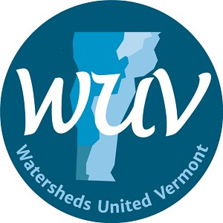

Strategic Plan
2020 - 2023

TABLE OF CONTENTS
MISSION 2
THEORY OF CHANGE 2
DESIRED RESULTS 2
STRATEGIC POSITION 3
THE WUV ECOSYSTEM 3
WUV Watershed Group Definition 5
STRATEGIC APPROACH 7
STRATEGIC PLAN 8

MISSION
Watersheds United Vermont (WUV) is a state-wide network of local groups dedicated to the health of their home watersheds.

Our mission is to empower community-based watershed groups in all parts of the state to protect and restore Vermont's waters.

THEORY OF CHANGE
WE BELIEVE THAT...
- Local groups are critical for watershed protection and restoration because of their local expertise, connections within their community, and representation of everyone within the watershed
- Local groups need resources, representation, and recognition to accomplish this work
- As a connected network, local groups are more impactful in their local watersheds
- Protection and restoration of our waters requires a holistic watershed approach, beyond the water’s edge
- In order to protect and restore our waters, we need to address water quality, aquatic and riparian habitat, flood resilience, aquatic organism passage, and watershed health

DESIRED RESULTS
WE WILL KNOW OUR WORK IS DONE WHEN...
- The accomplishments of Vermont’s community-based watershed groups are acknowledged and supported by decision-makers and the general public;
- Every watershed is supported by groups at the local level, and groups have the support and the security they need to plan and operate long-term;
- Watershed groups collaborate regularly with peers and partners, making the most effective use of shared resources;
- Members and partners have readily available information about events, resources and best practices to be effective;
- Watershed groups have funding for all aspects of watershed protection and restoration work including project development, design, implementation of projects and education and outreach in their communities; and
- Watershed groups play a central role in achieving a healthy and resilient future for all of Vermont’s rivers, streams, lakes, and ponds and the species that depend on them, including people!

STRATEGIC POSITION
WUV was created in 2014 by watershed organizations and partners in the wake of Tropical Storm Irene, a major climate event that illuminated the need for local watershed groups to become stronger by working together. WUV’s first strategic plan was created in 2015, identifying the important role WUV would come to play in building a network for local groups, providing access to resources for those groups, increasing skills and capacity of member organizations, and rolling out the Clean Water Initiative to build grassroots action to support state water quality goals. This plan was revisited in 2018 by the board which affirmed WUV’s mission and focus and updated goals and objectives. In 2019, significant changes at the state level forced WUV to examine and elevate its role in advocacy and resource redistribution. These changes included the Department of Environmental Conservation’s shift to a Block Grant model for distributing funds, proposed Clean Water Legislation that lead to an increase in WUV’s advocacy work, and the passage of Act 76 which named “Watersheds United Vermont and is Designees” in Tactical Basin Planning Statute to receive Basin Planning Funds and deemed that Basin Water Quality Councils were to be established with Watershed Groups as required participants. This strategic plan was built to support WUV’s more formal role as a funder and advocate on the statewide level maintaining focus on WUV’s core mission to serve and represent local watershed groups and their needs and interests. Planning efforts build from the previous plan and are informed by a strategic planning session at WUV’s annual conference in December,, a survey that was sent to WUV members and partners, and several facilitated WUV board strategy sessions.

THE WUV ECOSYSTEM
WUV operates within a larger ecosystem of local, regional, and statewide constituents who have roles to play in protecting and restoring Vermont’s waters.

The diagram below illustrates that WUV focuses its programming and capacity primarily on watershed groups because of the important role that local groups play, and because these groups do not have any other advocate or affiliation at the statewide level. WUV also serves partner groups, some of which also identify as watershed groups, who may or may not take shape through organizing structures such as Natural Resource Conservation Districts, conservation commissions, or lake associations. WUV also maintains close relationships with technical/service providers that can offer support to local groups and amplify relevant issues and priorities and who rely on watershed groups to help support and implement their projects and programs.. Also within the WUV program landscape are decision makers who create and enforce important regional and statewide policies, and benefit from knowing about the vital role watershed groups play in protecting and restoring Vermont’s waters. See below for more detailed description of each constituent group.

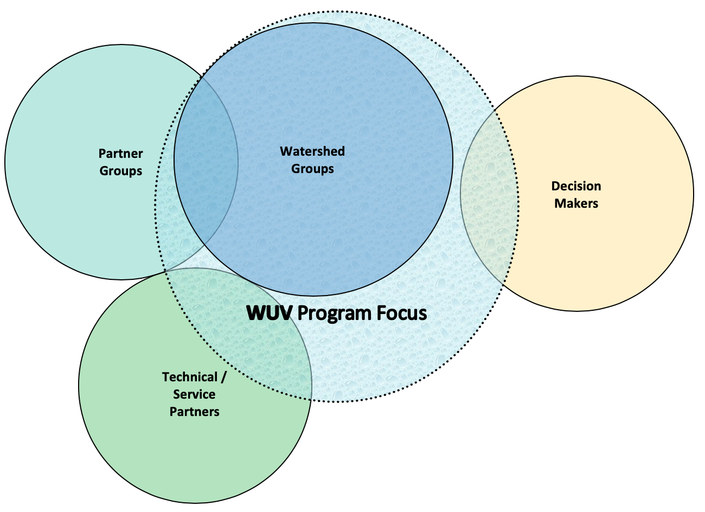
WUV understands each of these groups through the following definitions:
WATERSHED GROUPS
Ex: Friends of the Winooski River, White River Partnership, Missisquoi River Basin Association
For the purposes of this Act, a “watershed organization” is defined as a community-based organization working with individuals and communities in their local watersheds to protect and improve water quality, habitat, and flood resilience and to build social and ecological connections with Vermont’s waters. Watershed organizations work with all watershed constituents and do not represent a specific constituency or interest group. Some groups focus on a particular aspect of watershed protection, while others engage in a full suite of watershed protection activities.

PARTNER GROUPS
Ex: Natural Resources Conservation Districts, Lake Associations, Trout Unlimited groups, farmers watershed alliances, etc.
Partner Groups are organizations that are also embedded in the community and focus on one or a suite of watershed restoration and protection programs in their watersheds. They may focus on a specific sector; may not be solely focused on watershed restoration/protection; and/or may have another umbrella organization representing their organization. These groups may be direct partners to watershed groups in some watersheds or subwatersheds or may be the primary organization engaging in watershed protection and restoration work where no other watershed organization exists.

SERVICE/TECHNICAL PARTNERS
Ex: Regional Planning Commissions, advocacy organizations, state and federal agencies including DEC and Fish and Wildlife.
Technical/Service Partners are organizations and agencies who are engaged in water quality and/or watershed health work usually on a regional or state scale and partner with watershed organizations on particular aspects of the work. These partners often provide technical assistance or services to watershed organizations and also rely on watershed organizations to engage communities and to develop and implement projects.

DECISION MAKERS
Ex: Agency of Natural Resources, Vermont Legislature, etc.
Decision Makers develop laws and policies that directly impact the protection and restoration of Vermont’s waters. They also make decisions that impact watershed groups’ funding and ability to accomplish work.

WUV Watershed Group Definition
WUV has developed criteria for defining a watershed group based on: years of working with watershed organizations; input from the broader watershed community during a December 2019 conference; a survey of WUV members and partners in the winter of 2020; and a strategic planning process with the WUV Board during the winter/spring of 2020. WUV recognizes that different watershed group definitions exist and that there are groups doing watershed work that do not fully meet WUV’s criteria.

WUV plans to utilize this watershed group definition for 3 purposes:
- Defining WUV’s primary constituency and focus;
- Recommending eligibility for statutory membership as part of Basin Water Quality Councils; and
- Determining eligibility for Vermont Department of Environmental Conservation grants including Tactical Basin Planning support.

Watershed groups are formed at the community level; therefore there are basins in Vermont where a watershed group has not been formed. In some cases, conservation districts take on the primary role in watershed work in those areas and in other cases there is a notable lack of capacity for watershed work. For basins that lack an active watershed group, it is WUV’s intention to recommend groups that best align with the criteria below as a “watershed group” for service on that area’s Basin Water Quality Council. In these cases, WUV hopes that Clean Water Service Providers and Basin Water Quality Councils will recognize the need to help develop local watershed group capacity in a given area.

WUV Watershed Group Definition
Category | Criteria: A group must meet all criteria below
WHERE | A watershed group:  - focuses on the geographic area of their watershed; and  - are embedded in the communities in the watershed.
WHAT | A watershed group:  - is an organization or affiliated group;  - is guided by the watershed concept - the connection between land and water;  - primarily focuses on water- and watershed-related issues; and  - works to protect or improve water quality and watershed health.
HOW | A watershed group:  - assesses and/or monitors water quality and/or other indicators of watershed health and acts as the “eyes and ears” in their watershed;  - engages and educates people in the watershed; and  - works on one or a suite of watershed protection or restoration projects and programs.
WHO | A watershed group:  - works with all watershed constituents and does not represent a specific constituency or interest group.

STRATEGIC APPROACH
WE EMPOWER COMMUNITY-BASED ACTION TO IMPROVE WATERSHED HEALTH BY:
- Connecting Members and Partners to form a connect network
- Providing resources, training and information to watershed groups
- Representing Watershed Groups at the State Level
- Leveraging resources to expand the capacity of watershed groups;
- Sharing information and coordinating participation of local groups in regional and statewide decision-making and representing local groups at the statewide level; and
- Linking watershed groups with partners who can provide technical, financial, or other assistance.

In order to meet WUV’s mission, WUV engages all four of the constituent groups within the WUV ecosystem. The diagram below identifies WUV’s strategy for and desired impact on each group. WUV works primarily to serve watershed groups so that they are represented, informed, resourced and connected. WUV also supports partner groups who also work locally, and may identify as watershed groups, so that they too are informed and connected. WUV’s work with technical/service providers is to ensure that they are connected so that they may partner with local groups to accomplish common goals. WUV’s work with decision makers is to ensure that decisions made at the state level to protect and restore watersheds are informed by and represent work happening at the local level. It is through these results that WUV meets its mission to empower community-based watershed groups in all parts of the state to protect and restore Vermont's waters.
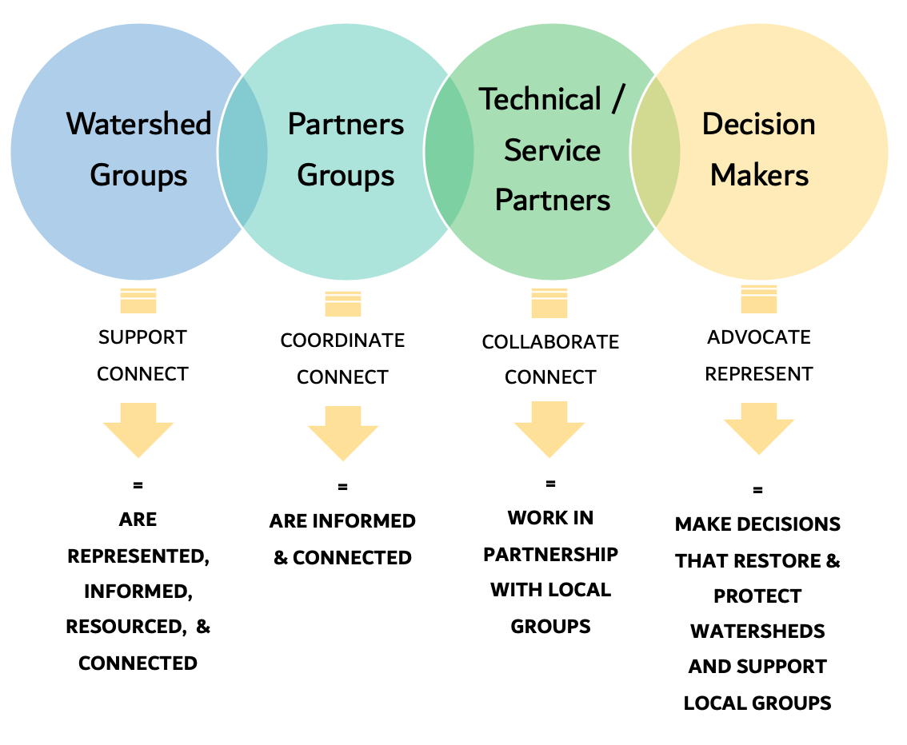

STRATEGIC PLAN
LEGEND | GOALS  A desired future state or definition of success for different areas in the organization Inspiring guideposts for what WUV can achieve that tie to the mission.  ↓  OBJECTIVES  The steps that create the future state described in the goal; what WUV will accomplish.  ↓  STRATEGIES  The activities that must be carried out; how WUV we will reach each objective.
GOALS | 1) | Build the capacity of watershed groups so that they can effectively protect and restore Vermont’s waters.
 | 2) | Support an informed and connected community of watershed groups and partner groups and create connections between local groups and technical/service providers.
 | 3) | Ensure that the work of watershed groups is a priority for decision makers at the state level to accomplish clean water and healthy watersheds throughout Vermont.
 | 4) | Establish organizational and financial stability for WUV.
OBJECTIVE  I. | Create networking and learning opportunities for watershed groups to have knowledge and tools they need to best accomplish their work.
STRATEGIES |  | A: | Host Annual Conference focused on both organizational and technical topics
 |  | B: | Coordinate formal networking and training opportunities (webinars, trainings, etc.)
 |  | C: | Facilitate informal networking and learning across watershed and partner groups
 |  | D: | Facilitate peer mentoring by connecting groups needing guidance with groups that have the relevant experience
 |  | E: | Leverage WUV’s listserv as an opportunity for groups to share information on best practices and methods
 |  | F: | Facilitate connections between watershed groups, partner groups and technical/service providers
OBJECTIVE  II. | Inform watershed groups about relevant issues and topics.
STRATEGIES |  | A: | Maintain WUV Listserv and send out weekly or bi-weekly WUV Updates
 |  | B: | Maintain and update WUV Website
 |  | C: | Participate in events and meetings and share relevant information with groups
 |  | D: | Facilitate the production, reproduction and/or distribution of relevant materials
 |  | E: | Inform watershed groups of key legislative and agency decisions to enable groups to advocate or participate if so desired
OBJECTIVE  III. | Increase funding to watershed groups and establish sustainable funding sources to expand capacity of groups to protect and restore Vermont’s waters.
STRATEGIES |  | A: | Research and identify funding opportunities for WUV to subgrant or for watershed groups to apply for directly
 |  | B: | Secure funding that can be subgranted to groups
 |  | C: | Create and effectively manage subgrant programs for watershed organizations
 |  | D: | Advocate for existing and additional resources for watershed groups
OBJECTIVE  IV. | Raise awareness of and advocate for watershed groups and watershed protection and restoration work.
STRATEGIES |  | A: | Participate on key state agency committees; meet with state agency staff and connect them to watershed groups
 |  | B: | Provide state legislators with information about the role watershed groups play
 |  | C: | Coordinate with statewide partner organizations acting as a representative for watershed groups to encourage collaboration and find common goals
 |  | D. | Provide testimony to Legislature on relevant proposed bills and coordinate watershed groups to provide testimony
 |  | E. | Provide feedback and comment letters to state agencies on programs, rule establishment and changes, policy and funding; coordinate watershed groups to provide feedback
 |  | F: | Promote watershed groups’ work via annual Accomplishments Report and other methods
OBJECTIVE  V. | Ensure that WUV is financially stable and has the organizational capacity to effectively meet other objectives.  * Led by Board of Directors
STRATEGIES |  | A: | Develop and implement a WUV governance calendar to ensure sufficient compliance, financial oversight, mission oversight, and strategic planning efforts.*  Including: Board Meetings, Budgeting Process, Financial Reporting, Board Orientation, Board Self-Evaluation, ED Evaluation, Financial Audit, Board Recruitment & Nominations, Annual Meetings, Operational Policy Review, Bylaw Review, Strategic Plan Dashboard, etc.
 |  | B: | Strengthen the capacity of the Board of Directors through clear expectations, representation, and established board policies and practices.*  Including: Board Policies, Bylaws, Standard Operating Procedures, Board Officer Job Descriptions, Committee Structure & Charters, Self Evaluation Process, Board Onboarding Materials and Process, Board Recruitment and Nominating Materials and Process, etc.
 |  | C: | Strengthen the capacity of the WUV Director with clear expectations, performance evaluation, and established staff policies and practices.*  Including: ED Job Description, ED Evaluation, ED Growth Plan, Compensation Review
 |  | D: | Share and build institutional knowledge through documentation of best practices, processes & procedures  Including: Employee Policies, Standard Operating Procedures, Emergency Succession Plan
 |  | E: | Analyze the legislative and statewide landscape and identify WUV’s strategic position within it; consider updates to the WUV mission, strategic plan, and structure accordingly
 |  | F: | Engage members and partners in providing feedback about their needs, WUV’s services and strategic position
 |  | G: | Evaluate and develop appropriate staff capacity to accomplish strategic goals
 |  | H: | Optimize organizational management through annual staff work plans
 |  | I: | Build a budget that will accomplish strategic goals
 |  | J: | Raise sufficient funds to accomplish strategic goals
 |  | K: | Evaluate and establish sufficient financial controls and infrastructure to meet the increased financial and legal obligations of the organization

