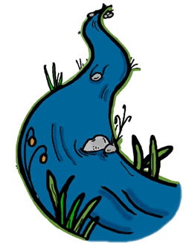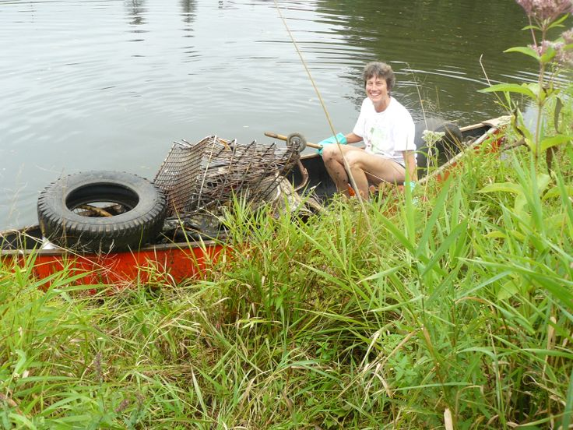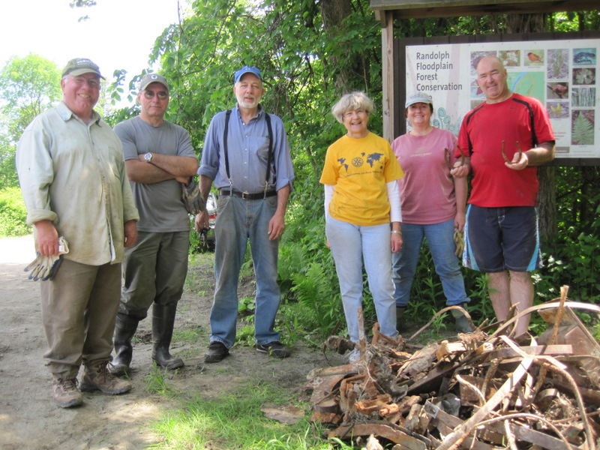

**River Cleanup  
Month**

**Information at:  
www.watershedsunitedvt.org**

**Join Your Local Cleanup**

**September is Vermont’s**